**ANAND KUMAR MAURYA** 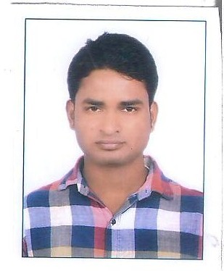

S/O- RAKESH KUMAR MAURYA

Address-Vill&Post- katrauli, Pratapgarh

: +91-9695759696

**Email**: anandkumarmaurya9319@gmail.com

Application for the post: : Graduate Engineering Training

( Reference Job: 25-06-2018 @23:20.0)

 **OBJECTIVE**

*Aspiring to work with a growing organization that offers a challenging environment where I can carve a niche for myself and*

*Effectively deliver towards contributing to the organization’s target & aspirations.*



**PROFILE**

* **Vibran**t, **self-motivated** & **result-oriented** individual aspiring to work with a growth-oriented organization, dedicated to put in a value-adding service, through the knowledge & skills I have attained.
* Strong **interpersonal & problem-solving** skills with the flexibility to work cohesively as part of a multidisciplinary team, complimenting the skills of others.
* **Quick learner &** **highly energetic** having a keen aptitude for learning and productively applying new knowledge resourcefully.



**EDUCATIONAL QUALIFICATION**

|  |  |  |  |
| --- | --- | --- | --- |
| **Qualification** | **University/Board** | **Passing year** | **Percent** |
| B.Tech. Mechanical Engineering In Industrial production | Dr.APJ Abdul Kalam Technical University (A.K.T.U) | 2018 | 72.7% |
| Diploma Mechanical Engineering  in Automobile | Board Of Technical Education Uttar Pradesh,Lucknow | 2014 | 73.2% |
| INTERMEDIATE | Uttar Pradesh Board | 2009 | 62% |
| HIGH SCHOOL | Uttar Pradesh Board | 2007 | 60% |



**TECHNICAL EXPERTISE**

* **Auto CAD**(2D,3D)
* **CNC programming**
* **Automobile engine & technology**
* **Excel , Power point'**
* **Machine design**

**TRAINING AND WORKSHOP**

* **Summer Training**
* Four weeks vocation training in **UPSRTC** Allahabad (UP) **in 2013**
* Four weeks vocation training in  **IFFCO** Allahabad (UP**) in 2017**

**AREA OF INTEREST:**

1: Automobile

2: Power plant

3: Manufacturing



Practical Training And Experience

* **Work in At TATA MOTORS LTD. PANTNAGAR (U.K)…From 01.07. 2014 TO 03.08.2015**
* **Working in sumo production assembly line as a supervisor and also handling the office**

**PERSONAL DATA**

Nationality : Indian

Date of Birth : 01-JAN 1993

Sex : Male.

Religion Hindu.

Marital Status : Unmarried.

Language : Hindi & English.